Controller (application) Analog/Digital
Block diagrams of open and closed loop control.

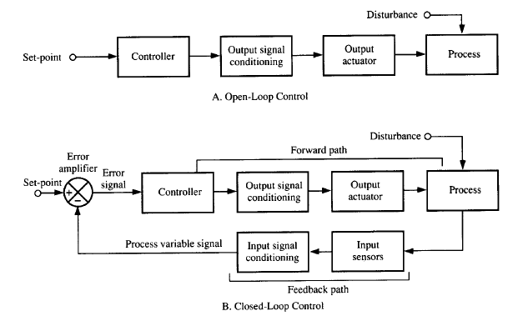
Simple ON/OFF controller (Temperature controller)

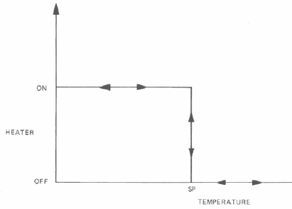
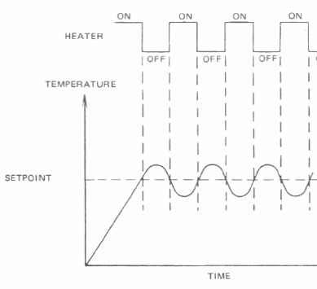

Practical circuit: The controller is a comparator

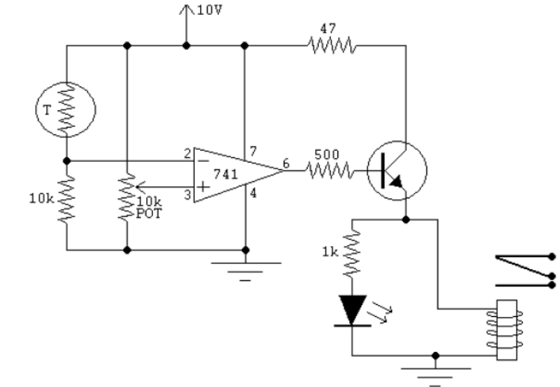
NTC Thermistor ( temp sensor) + Potan (Ref value) Op-Amp (simple on-off controller without feedback)

Algorithm of simple ON/OFF controller

T = Temp
T0 = Reference value
Function heater(T,T0)
IF T >T0
Turne_on_heater
Else
Turne_off_heater
End if
End heater

ON/OFF controller with deadband (Hysteresis) controller

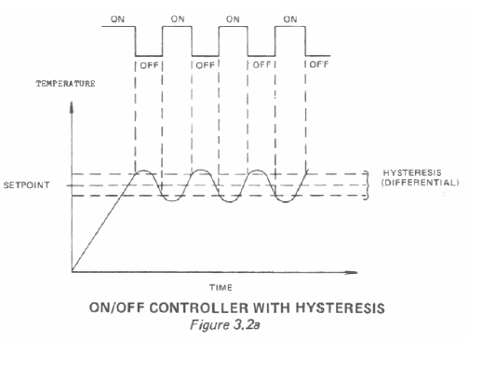
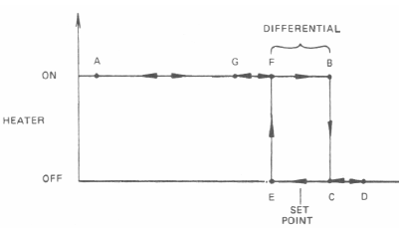

Practical circuit: deadband (Hysteresis) controller
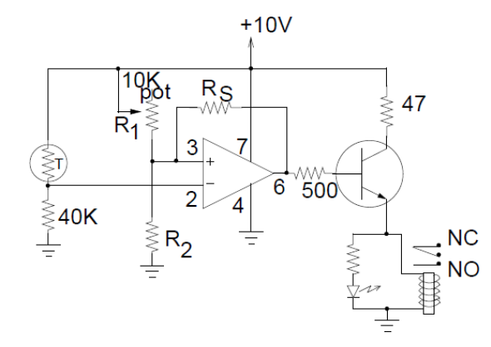
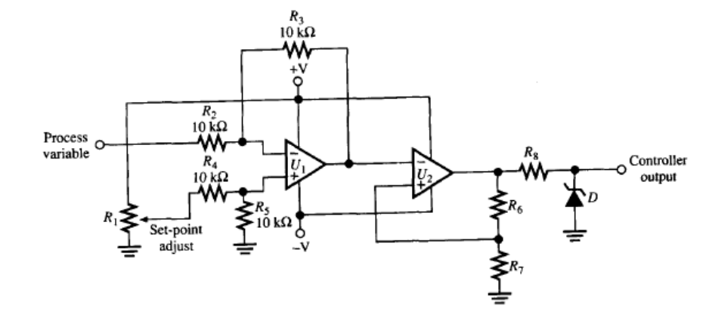
ON/OFF controller with deadband (Hysteresis) using comprator and D Flip Flop
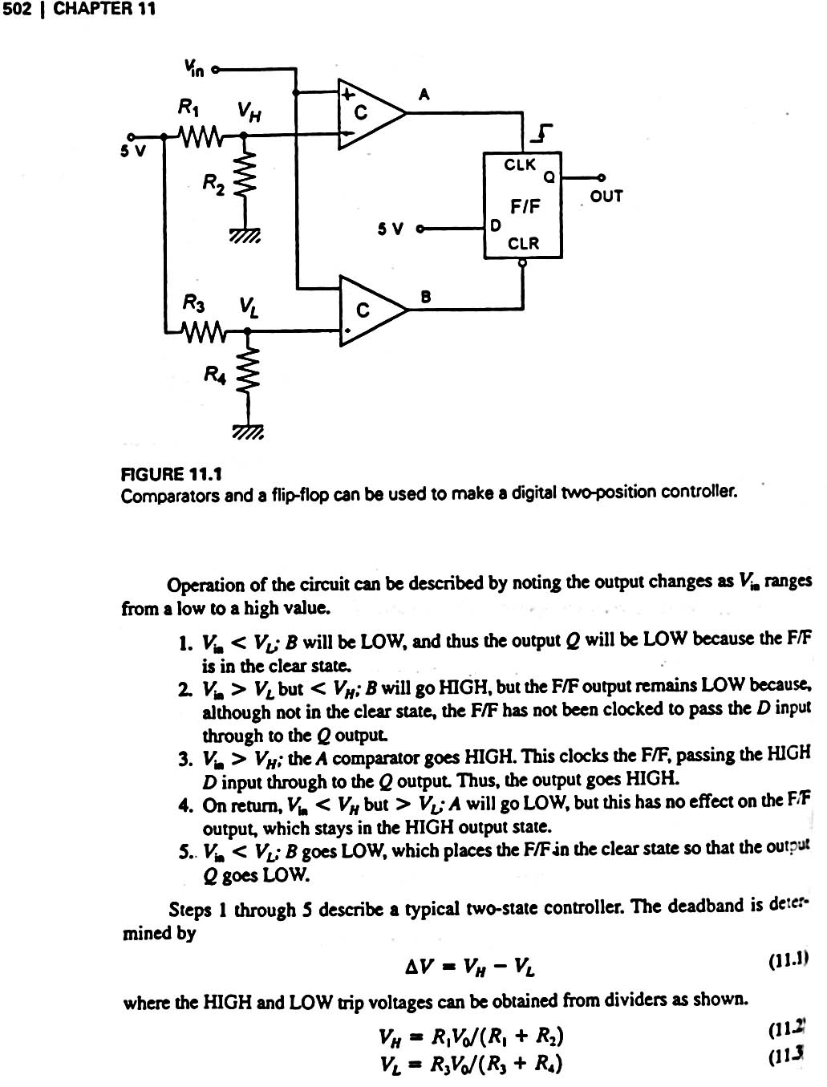

Algorithm of ON/OFF controller with deadband (Hysteresis)

DEGIN
DO FOREVER
Measure T
IF T < T_{ref}-ΔT
Turn ON device
ELSE IF T> T_{ref}+ΔT
Turn OFF device
END IF
ENDDO

Three position controller
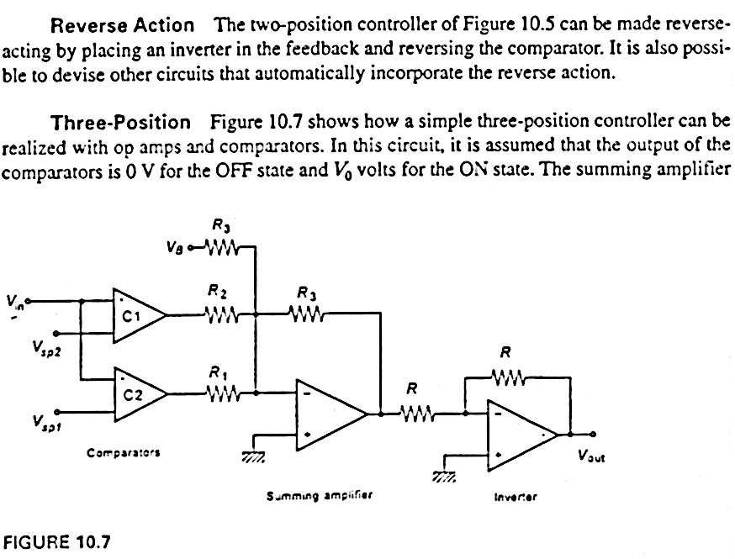

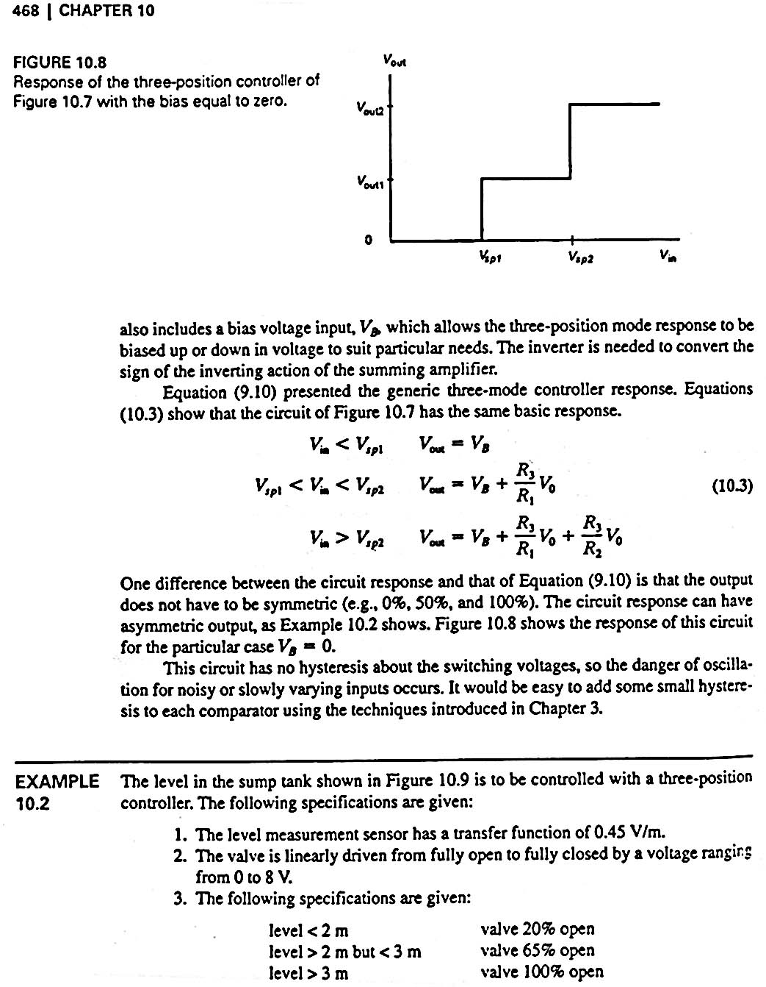

Example:
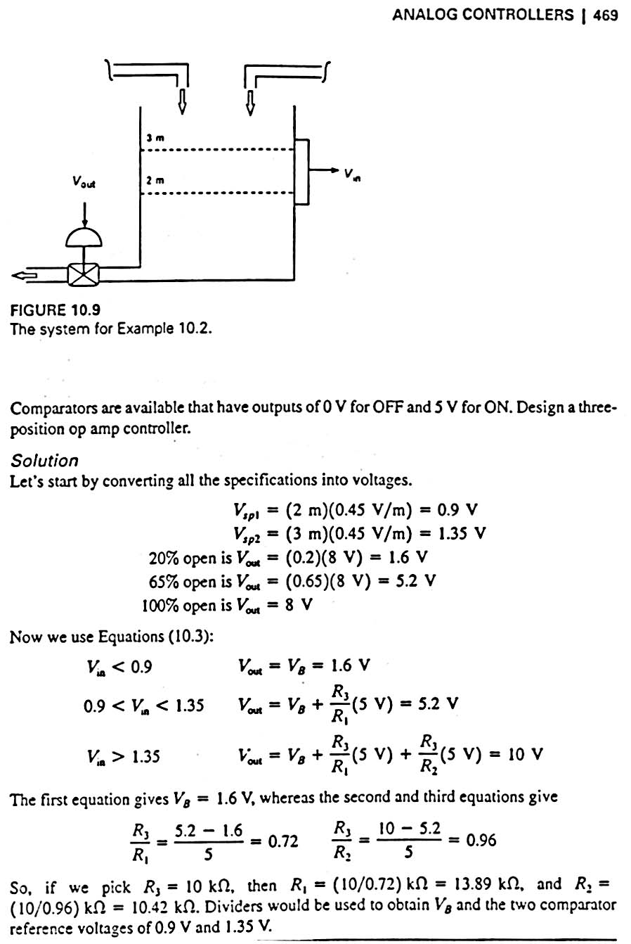

Continuous Controllers (Closed loop)

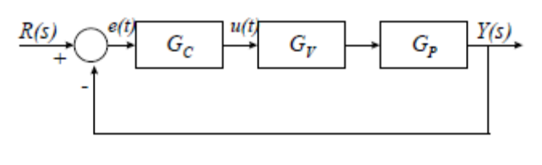
where:
R(s) is the desired output value, or setpoint.
Y(s) is the actual output value.
GP represents a process
Gc represents a controller
Gv represents a control element, such as a valve or the ailerons on an aircraft
The closed loop TF of this system is:
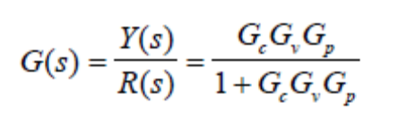
setpoint it is capable of adjusting the operating conditions of the process to ensure that the output deviates within an allowable range of this value.Although not included in this system the controller must also maintain the output at its setpoint if disturbed. Although the optimal form that a controller can take is very much dependent upon the characteristics of the system, one particular form of controller, known as a 3-term controller, has been devised to be suitable for many general types of system. The performance of such controllers, although not optimal, is often adequate.The 3-term controller is made up of three distinct elements, each of which is detailed here.

Proportional Controller This is the simplest form of feedback control. The control signal, u(t), is made to be linearly proportional to the error in the measured output: u(t) = KP * e(t)
The transfer function for the controller is given by:

GC = KP

A large error results in a large output from the controller. A small error results in a small output from the controller. The graph below shows how the output of the controller varies with error

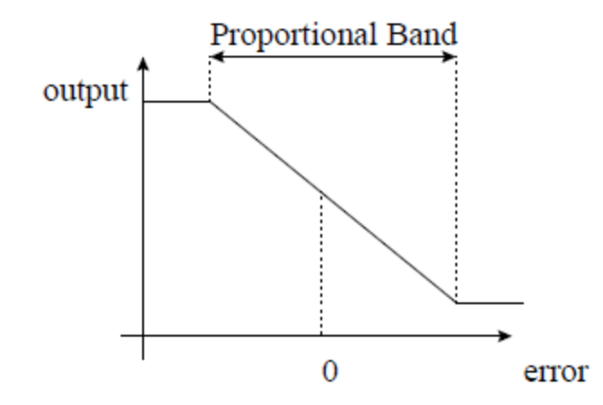
Note that the graph does not continue as a straight line forever. This is because in real life, the output of the controller tends to be bounded. For example the signal to a valve cannot be outside the range 0% open to 100% open. Similarly, if the speed of a motor is being controlled, a constraint on the motor may be that the maximum supply voltage is 240V. The range over which the controller responds with a constant gain is known as the proportional band.KP = 100 / Proportional Band (say) Let us now consider the response of a first-order system under proportional control:

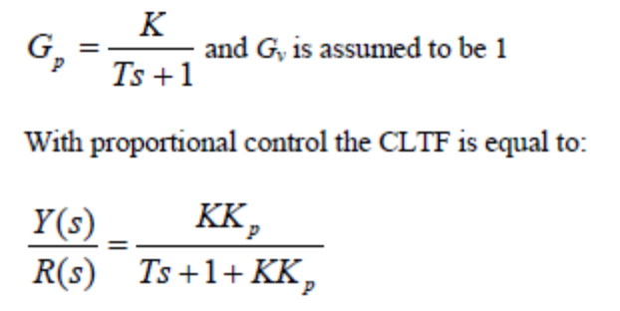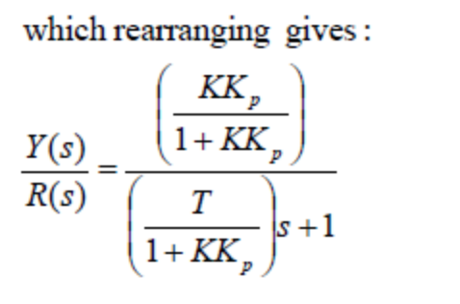

The CLTF shows that as the gain of the controller is increased, the overall gain of the system approaches unity and the time constant gets smaller and smaller. The addition of proportional control also affects the characteristic equation, which implies that the response of the system will also change. The time constant is reduced as the gain of the controller increases and therefore the system response will be faster.

Steady State Error

The purpose of the controller is to maintain the system output at the setpoint value. To determine whether or
not a proportional controller achieves this it is necessary to determine the steady state value of the output (i.e. the output as time → ∞) after a change in setpoint. This calculation is simplified by using the Final Value Theorem of Laplace transforms, which states:

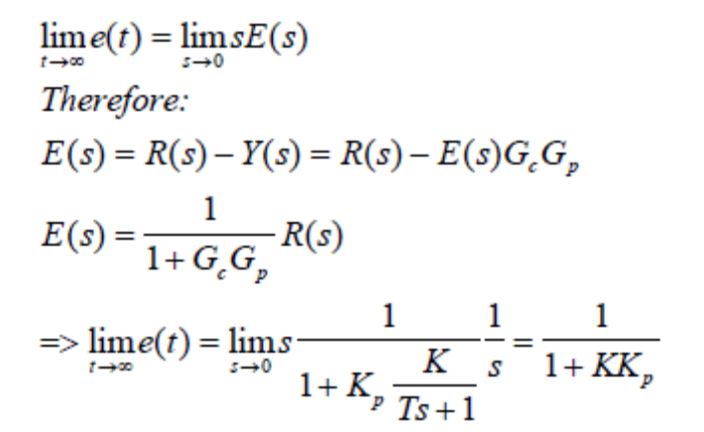
This equation states that there will always be an error, unless the value of Kp is equal to ∞. The size of the
error is inversely related to the value of the proportional gain. The response of the first order system:

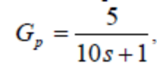

to a unit step change in setpoint, for various values of proportional gain is displayed in the graph below:

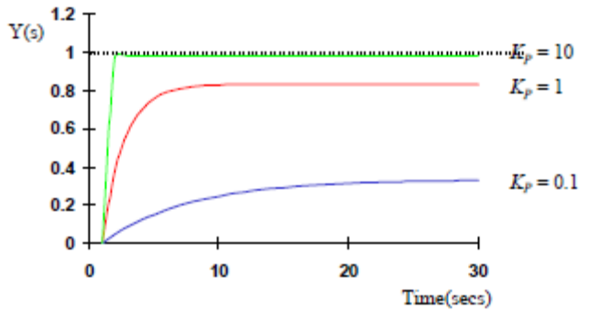

Integral Control

Integral control adjusts the output of the controller so that it is proportional to the integral of the error signal:
The output of an integral controller is given by:

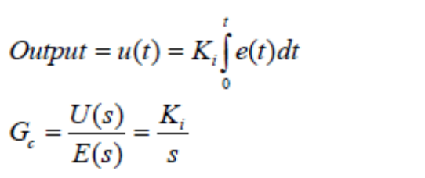The output of the controller with respect to the size of the error is demonstrated in the figure below:

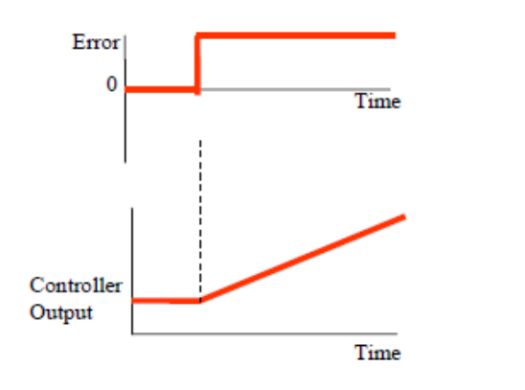
Example

What will be the steady state error in the following system when there is a unit step change in setpoint?
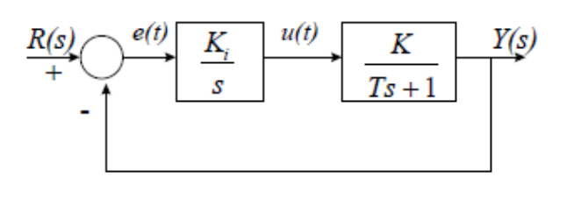
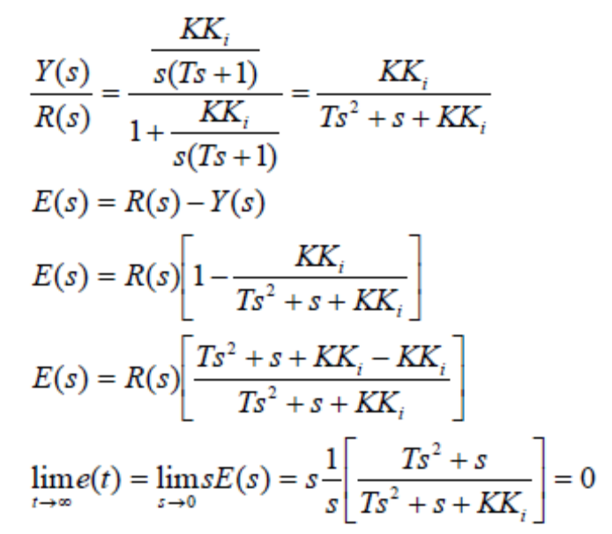

This example demonstrates that integral action can be used to eliminate steady state offsets. Provided there is an error signal, the controller output will continue to change, thus driving the system until the error becomes 0. Unfortunately, using integral action alone can lead to poor damping, which causes the response of the System to become more oscillatory. To avoid this combination of proportional and integral control is often used (PI control) - Two Term Control.

Proportional plus Integral Control

The output of a PI controller is given by:
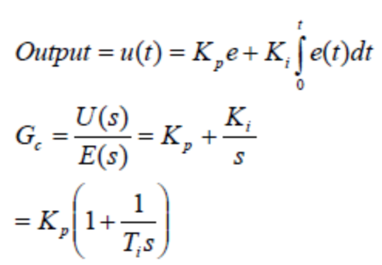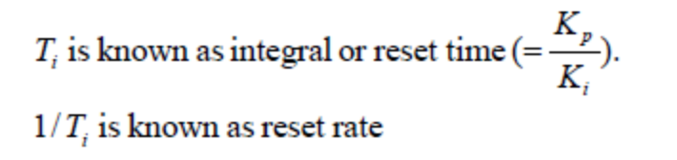
Schematically a PI controller can be represented by the following block diagram:
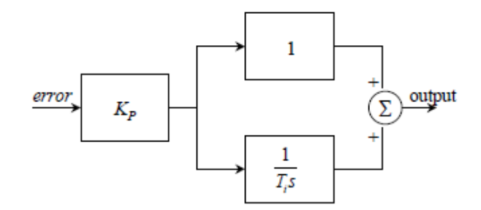
The figure below shows the output of a PI controller against the error input.

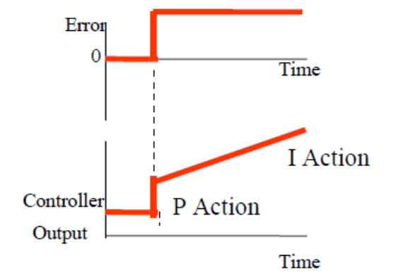

The graph below shows the response of the system:

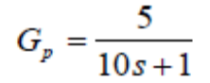

to step changes in set-point for varying values of the integral action. For each curve the value of the gain is fixed.

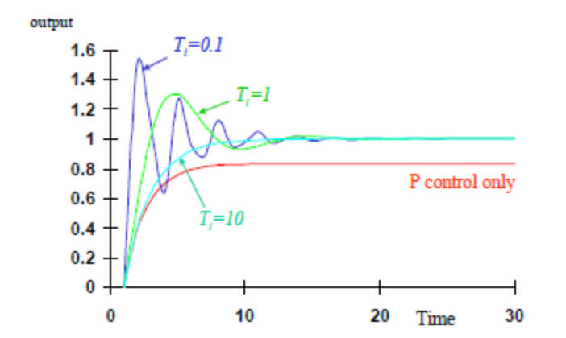

To summarise the observations from this graph, increasing the integral action, i.e. reducing the value of
TI, increases the amount of oscillation in the system.

Derivative Control

The final element of a 3-term controller is derivative action. Derivative control attempts to anticipate future error values from the rate of change of error in the control algorithm. The output of a derivative controller is set to be proportional to the rate of change of error: Kd is the derivative gain

The relationship between error and controller output is shown below:

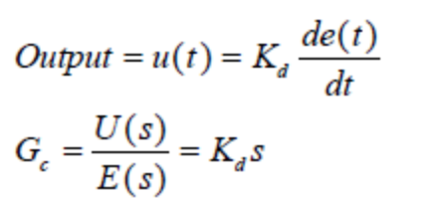

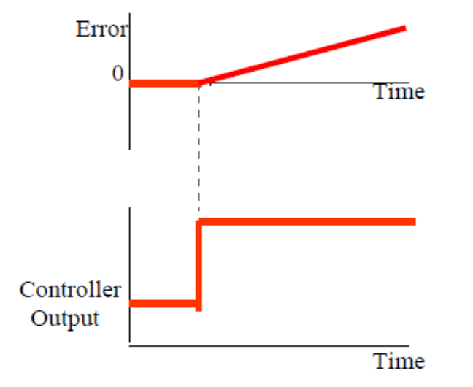
The characteristics of a derivative controller can be summarised as follows:
- Derivative control increases the
- Derivative control will be insensitive to constant or slowly changing errors and is therefore typically used with other forms of controller.

Proportional plus Derivative (PD) Control

As explained above, proportional control can produce oscillatory behaviour. Since derivative control
increases stability and consequently reduces oscillations, for those systems where it is important to minimise the amount of oscillation, PD control is applied. It should be noted that PD control will produce a steady state error unless the system contains an integrator. For many servo-mechanical systems, such as positional control by motors, there is an integrator (position is the integral of velocity – velocity = rate of change of position) and therefore PD control is suitable. The output of a PD controller is given by:

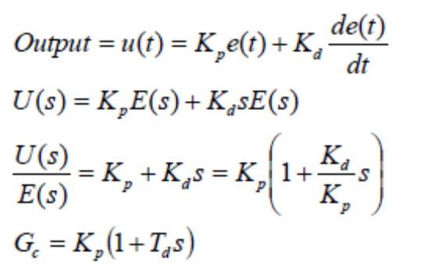
where Td = derivative time constant
The response of a second order system to a step change in input under both proportional and PD control is
shown in the graph below. In each case the value of the proportional gain is kept constant.

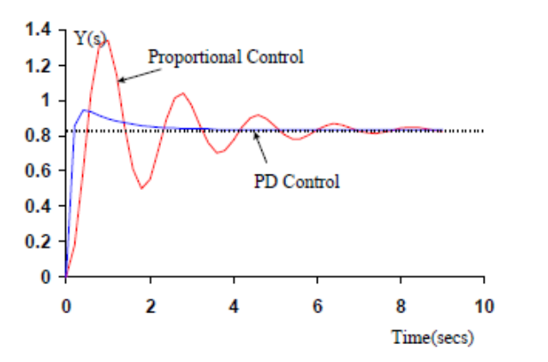
Since there is typically still an offset with PD control, Proportional plus Integral and Derivative control is
often used. This is known as PID or 3-term control.

Proportional plus Integral plus Derivative (PID) Control

The output of a PID controller is determined as follows:
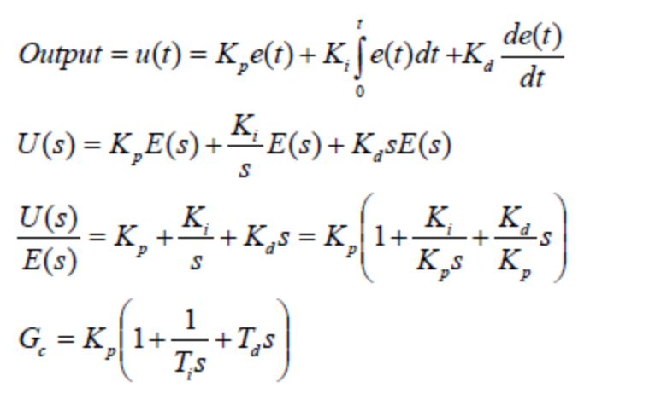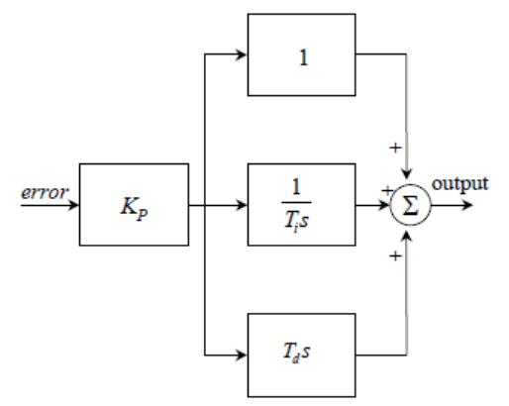
Once the type of controller has been determined for a particular system, the values of the controller constants, the proportional gain, the reset rate and the derivative time, must be determined. The determination of these values is known as Controller Tuning. For a PID controller it is not a trivial task, for example large values of proportional gain may increase the speed of response but they will also reduce the stability of the system. Large values of the reset rate will mean that the steady state offset is eliminated but will also increase the oscillations of the system. A large derivative time will increase the stability of the system but may also produce poor control if the measured signals contain large amounts of noise. The next section describes a number of techniques for tuning PID controllers.

Controller Tuning

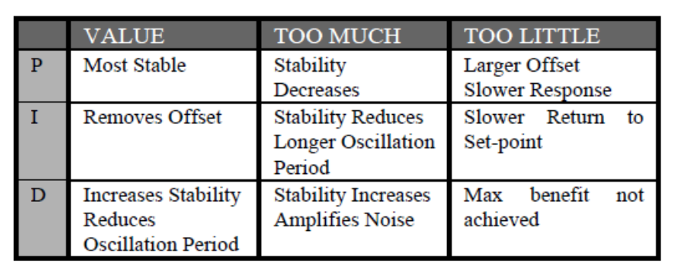

DISCRETE CONTROLLER

A discrete-time system can be in many different forms, depending on the type of input and the type of sensor used. Figure shows a discrete-time system where the reference input is an analog signal, and the process output is also an analog signal. Analog-to-digital converters are then used to convert these signals into digital form so that they can be processed by a digital computer. A zero-order hold at the output of the digital controller approximates a D/A converter which produces an analog signal to drive the plant. In Figure the reference input is a digital signal, which is usually set using a keyboard or can be hard-coded into the controller algorithm. The feedback signal is also digital and the error signal is formed by the computer after subtracting the feedback signal from the reference input. The digital controller then implements the control algorithm and derives the plant.

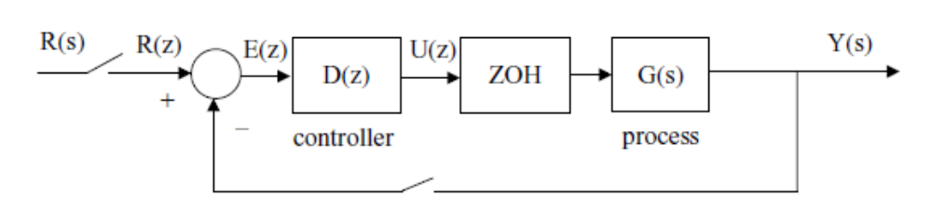

Discrete-time system with analog reference input

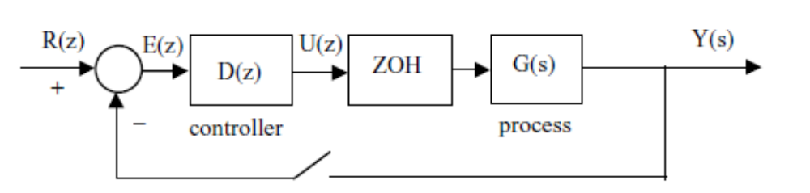

Discrete-time system with digital reference input

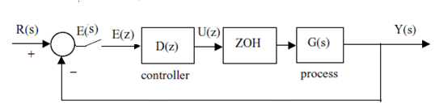
Discrete-time system with Analog error calculation .(Digital controller samples error)

PID CONTROLLER
The proportional–integral–derivative (PID) controller is often referred to as a ‘three-term’
controller. It is currently one of the most frequently used controllers in the process industry. In
a PID controller the control variable is generated from a term proportional to the error, a term
which is the integral of the error, and a term which is the derivative of the error.
_ Proportional: the error is multiplied by a gain Kp. A very high gain may cause instability,
and a very low gain may cause the system to drift away.
_ Integral: the integral of the error is taken and multiplied by a gain Ki . The gain can be adjusted
to drive the error to zero in the required time. A too high gain may cause oscillations and a
too low gain may result in a sluggish response.
_ Derivative: The derivative of the error is multiplied by a gain Kd. Again, if the gain is too
high the system may oscillate and if the gain is too low the response may be sluggish.

Discrete PID controller
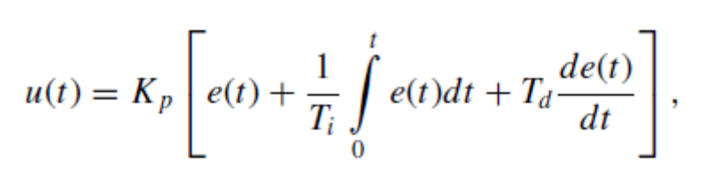
where u(t) is the output from the controller and e(t) = r (t) − y(t), in which r (t) is the desired set-point (reference input) and y(t) is the plant output. Ti and Td are known as the integral and derivative action time, respectively. Notice that this Formula is sometimes written as

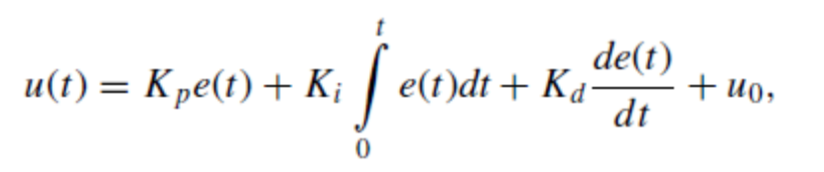
Where:
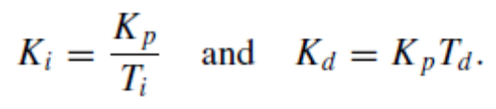
To implement the PID controller using a digital computer we have to convert controller form from a continuous to a discrete representation. There are several methods for doing this and the simplest is to use the trapezoidal approximation for the integral and the backward difference approximation for the derivative:

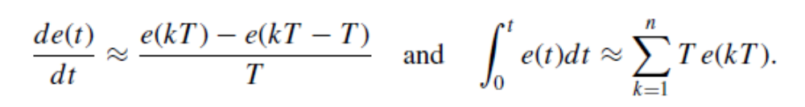
Digital PID controller becoms:
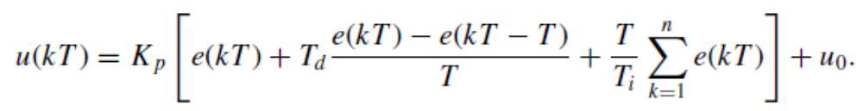
The PID given is now in a suitable form which can be implemented on a digital computer. This form of the PID controller is also known as the positional PID controller. Notice that a new control action is implemented at every sample time.

Digital PID controler can be written as:
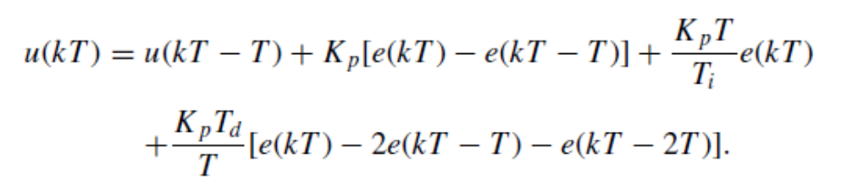
This form of the PID controller is known as the velocity PID controller. Here the current control action uses the previous control value as a reference. Because only a change in the control action is used, this form of the PID controller provides a smoother bumpless control when the error is small. If a large error exists, the response of the velocity PID controller may be slow, especially if the integral action time Ti is large. The two forms of the PID algorithm may look quite different, but they are in fact similar to each other.

PID controller in software: Proportional Mode:

The proportional mode is provided through the software by an equation that is entirely like the analog equation. Because we are expressing the error as a fraction of range, what is calculated is the fraction of the maximum output.

P = P0 + KP * DE
POUT = P * ROUT

In software:
Proportional gain, integral gain , derivative gain firstly shown as variables.(P0 =output of controller when error =0)
- Read set point
- Read process variable
- Calculate error (DE = DV-DSP); error as a fraction of range
- U =Kp.DE
- P = P0+U; P0 output with no error
- Output P (to output port or Other module(PWM,..)
- Goto 1

In integral controller: The simplest of error integral is called rectangular. It is uused in software :
- Read set point
- Read process variable
- Calculate error (DE = DV-DSP)
- Sum =Sum+DE
- PI = KI.DT.SUM
- Output PI
- Delay (DT)
- Goto 1

Derivative mode:
Derivative Mode The derivative controller mode, also called rate, derives a controller output that depends on the instantaneous rate of change of the error
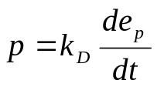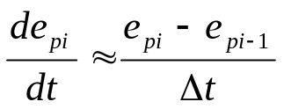The gain expresses the precent controller output for each percent/second change in error. This mode is implemented in computer control by calculating an approximate drivative of the error from the data samples. A derivative is defined as the rate at which a quantity is changing at an instant in time. We can calculate only the rate at which it is changing over the sample period Δt, which is therefore only an approximation. In terms of an equation, this is
where
e_{pi} = present error sample
e_{pi-1} = previous error sample
Δt = time between samples

- Read set point
- Read process variable
- Calculate error (DE = DV-DSP)
- DDE = DE-DEO
- DEO =DE, change of present error with last error
- PD = KD.DDE/DT
- OUTPUT PD
- START DELAY (DT)
- GOTO 1

DT represent the actual time between samples in the hardware

Example program (PID controller in speed control) in C like code:
//***********************Init***************
error=ref-speed; //actual error=reference-actual speed acquisition
if(IsOverflow()) error=127; //error saturation(Limits of signed byte)
else if(IsUnderflow()) error=-128;
//********** Proportional action****************
prop=kp*error; //sword variable=costant*sbyte variable
//************** End_proportional action ******************
//************** Integral action **************************
{integral=integral+error; //actualisation of integral factor
integ=ki*integral; //sword=costant*sbyte
//**************** End_integral action********************
//******************** Derivative action *****************
derivative=error-error_old; //actualisation of derivative component
der=kd*derivative;
//*************** End_derivative action ******************
error_old=error; //store actual error for next control step
increment=prop+integ; //sum of component integral and proportional
increment=increment+der; //sum of component derivative

//******************* End of PID regulator *************

PID CONTROLLER IMPLEMENTATIONS:

PID controllers are very important in many process control applications. In this section we shall look at the realization of this type of controller. The z-transform of the PID controller.
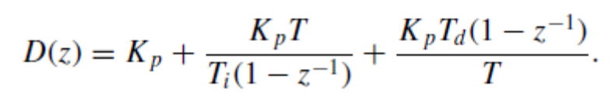

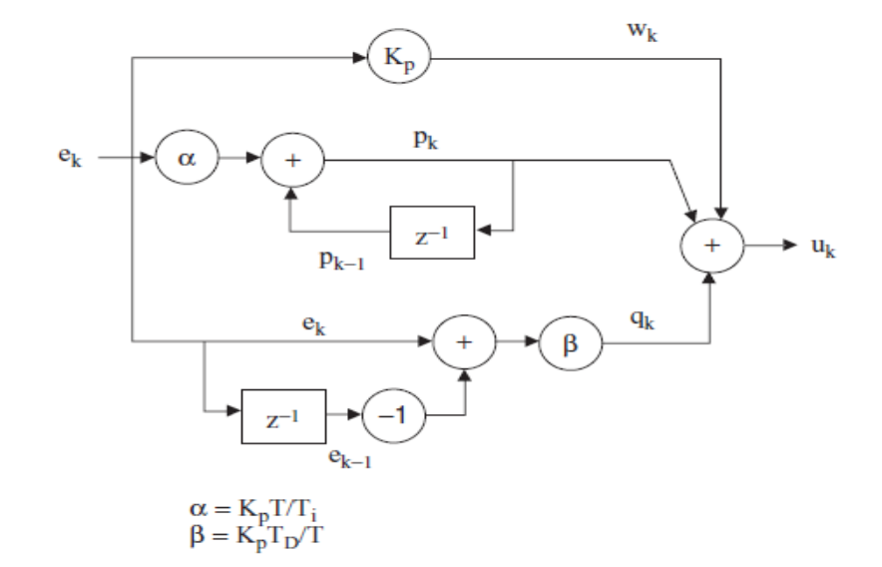

As shown in above Figure this transfer function may be implemented as a parallel structure by summing the proportional, integral and derivative terms.
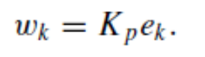
proportional section,

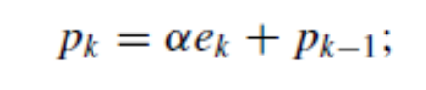
for the integral section,

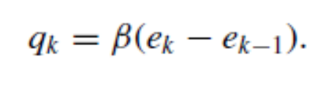
and for the derivative section,

The output is given by
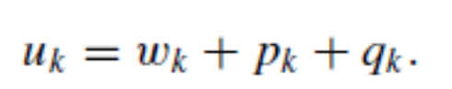

MICROCONTROLLER IMPLEMENTATIONS

There are several methods that can be used to implement the controller algorithm. One of the most common, which has the advantage of accurate implementation, is the use of a timer interrupt to generate the required loop delay (or the sampling interval). In this method the software consists of two parts: the main program and the interrupt service routine. As shown in Figure, in the main program various variables, as well as the A/D converter and the timer interrupt mechanism, are initialized. The timer is set to interrupt at an interval equivalent to the sampling interval of the required digital controller. The main program then enters a loop waiting for the timer interrupts to occur. Whenever a timer interrupt occurs the program jumps the interrupt service routine (ISR) as shown in Figure, and it is within this routine that the actual controller algorithm is implemented. The error signal is obtained by calculating the difference between the reference values and measured values. The algorithm is then implemented and the output sample for the current sampling time is obtained. A preprocessing step is then performed by updating the variables for the next sample. On return from the ISR, the program waits in the main program until the next sampling interval, and the above process repeats.

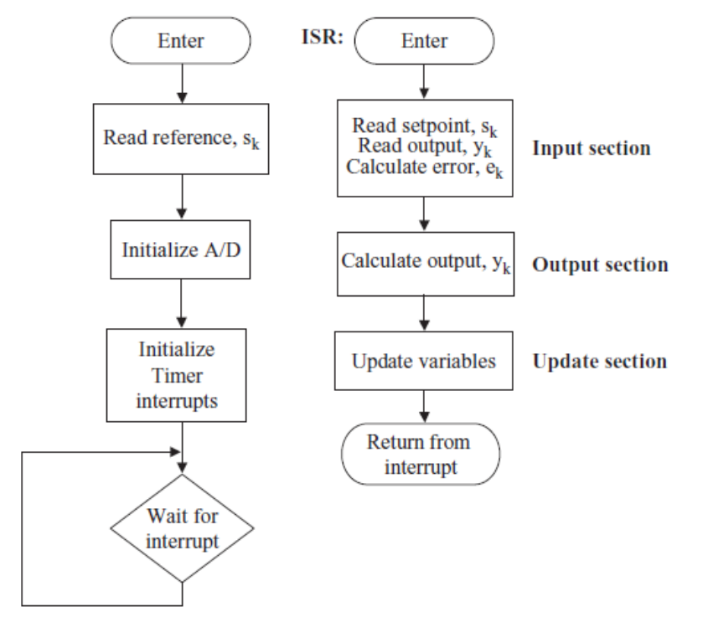
Controller implementation: (a) main program; (b) interrupt service routine

Example application: Liquid Level Digital Control System:

Figure shows a typical liquid level control system. Liquid enters the tank using a pump, and after some processing within the tank the liquid leaves from the bottom of the tank. The requirement in this system is to control the rate of liquid delivered by the pump so that the level of liquid within the tank is at the desired point.

A constant voltage will be applied to the pump so that a constant rate of liquid can be pumped to the tank. The height of the liquid inside the tank will then be measured and plotted. A simple model of the system can then be derived from this response curve. After obtaining a model of the system, a suitable controller will be designed to control the level of the liquid inside the tank

Water tank. This is the tank where the level of the liquid inside is to be controlled. Water is pumped to the tank from above and a level sensor measures the height of the water inside the tank. The microcontroller controls the pump so that the liquid is at the required level. The tank used in this case study is a plastic container with measurements 12 cm × 10 cm × 10 cm.Water pump. The pump is a small 12V water pump drawing about 3A when operating at the full-scale voltage. Level sensor. A rotary potentiometer type level sensor is used in this project. The sensor consists of a floating arm connected to the sliding arm of a rotary potentiometer. The level of the floating arm, and hence the resistance, changes as the liquid level inside the tank is changed. A voltage is applied across the potentiometer and the change of voltage is measured across the arm of the potentiometer. The resistance changes from 430_ when the floating arm is at the bottom (i.e. there is no liquid inside the tank) to 40_ when the arm is at the top.

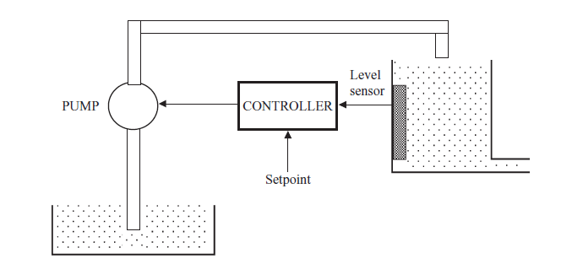

Block diagram of the system
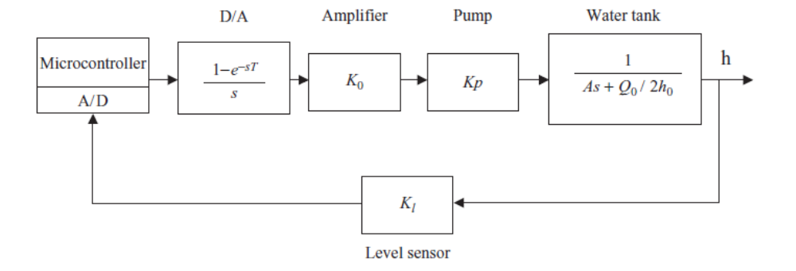

A typical liquid level control system

The PIC16F877 incorporates an 8-channel, 10-bit A/D converter. D/A converter. An 8-bit AD7302 type D/A converter is used in this project. In general, any other type of D/A converter can be used with similar specifications. Power amplifier. The output power of the D/A converter is limited to a few hundred milliwatts, which is not enough to drive the pump. An LM675 type power amplifier is used to increase the power output of the D/A converter and drive the pump. The LM675 can provide around 30W of power.

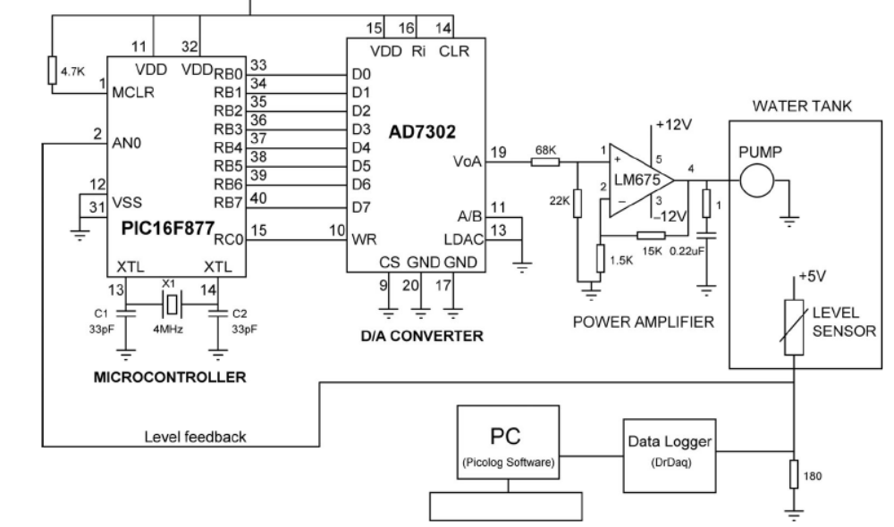
Hardware set-up to record the step response

Realization of the controller

A parallel PI controller was realized in this case study. The controller is in the general form of the PID controller as presented before with the derivative term set to zero

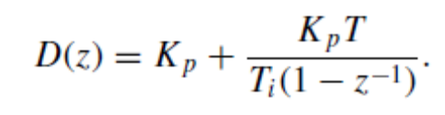

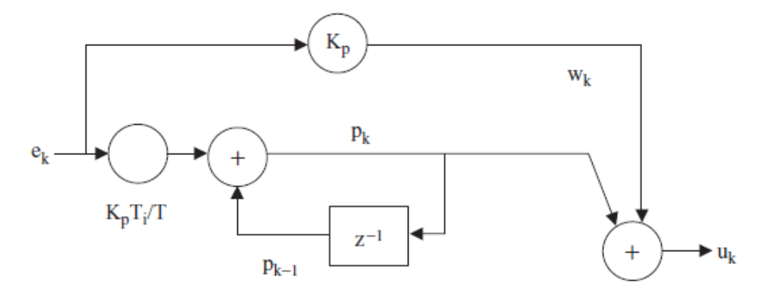

The controller software is shown in next figure. The PI algorithm has been implemented as a parallel structure. At the beginning of the program the controller parameters are defined. The program consists of the functions Initialize AD, Initialize Timer, Read AD Input, and the interrupt service routine (ISR). The A/D converter is initialized to receive analog data from channel AN0. The Read AD Input function reads a sample from the A/D converter and stores it in variable yak . The timer is initialized to interrupt every 10 ms. At the beginning of the ISR routine, the PI algorithm is implemented after every 10th interrupt, i.e. every 100 ms. This ensures that the controller sampling time is 100 ms. The ISR routine reads the output of the level sensor and converts it to digital. Then the PI controller algorithm is implemented. Notice that in the algorithm the input of the D/A converter is limited to full scale, i.e. 255. After sending an output to D/A, the ISR routine re-enables the timer interrupts and the program waits for the occurrence of the next interrupt.
The step response of the closed-loop system is shown in Figure below Here, the reference
input was set to 2280. Clearly the system response, although noisy, reaches the set-point with
no steady-state error, as desired.

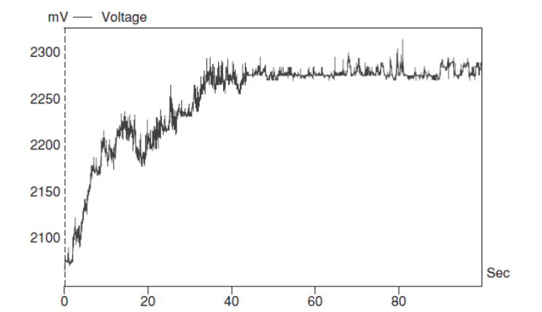

Step response of designed system

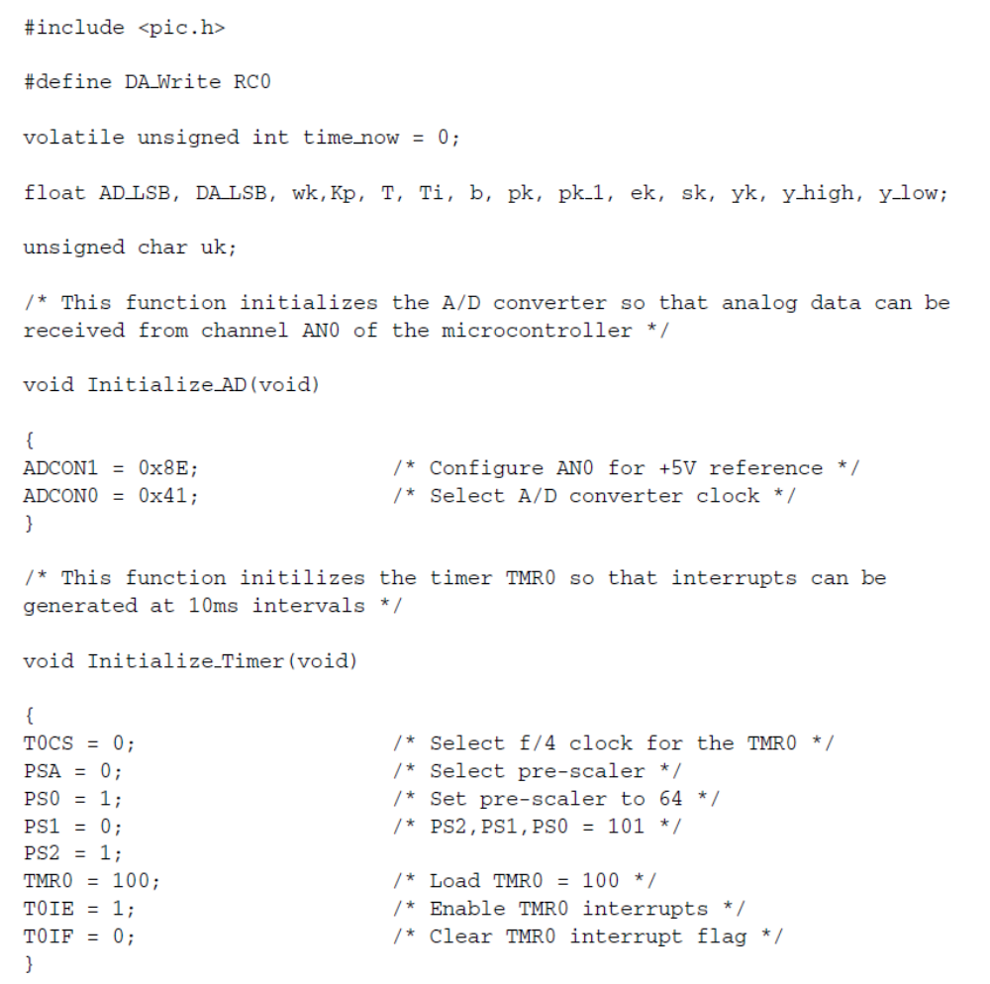
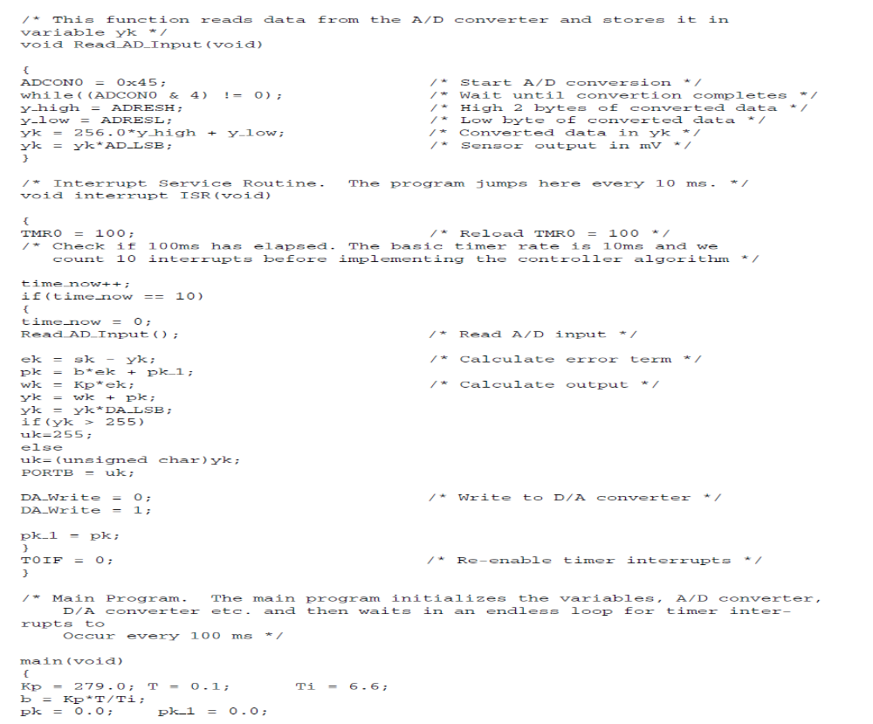

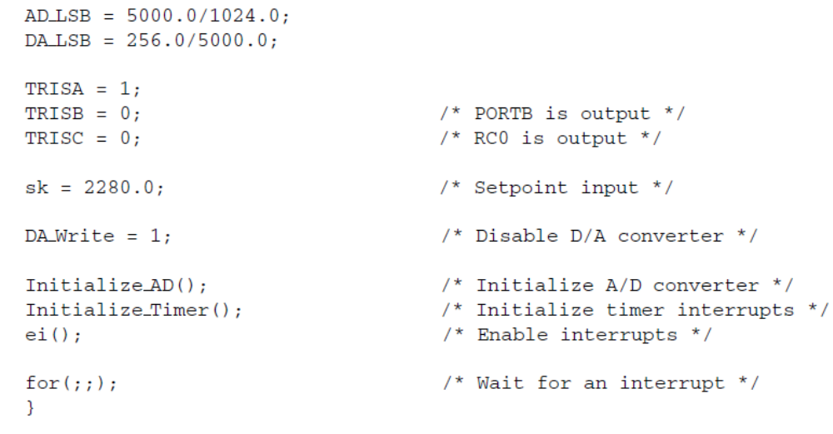

Open loop temperature control ( Monitoring)

Designing a microcontroller based temperature measurement system using an RTD:
This project measures the temperature with a Platinum RTD and then displays on a LCD every second

RTD principles
The term RTD is short for Resistance Temperature Detector. The RTD is a temperature sensing device whose resistance increases with temperature. RTDs are quite linear devices and a typical temperature-resistance characteristic is shown in figure:
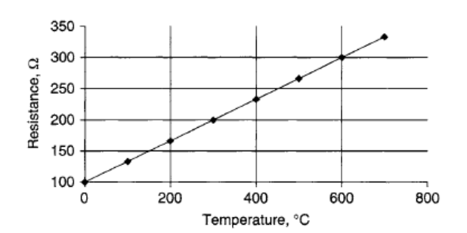
Temperature-resistance relationship of the RTDs
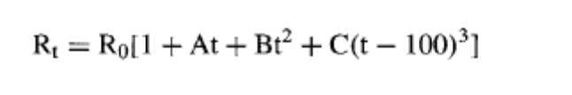
Temperature Can be calculated as: (A, B, C) are constant.
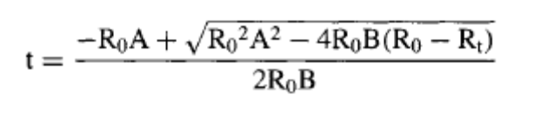
Simple voltage source circuit

Figure shows how an excitation current can be passed through an RTD by using a constant voltage source. RTDs give analogue output voltages and the measured temperature can simply be displayed using an analogue meter ( voltmeter). Although this may be acceptable for some applications, accurate temperature measurement and display require digital techniques.:
Vs = source voltage, VT = a votage proportional temperature
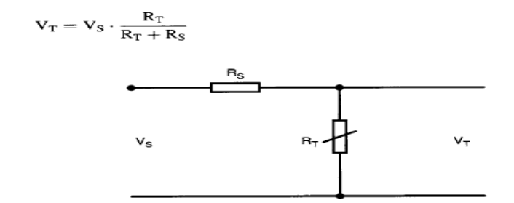
A complete temperature measurement system will be described in this section using an RTD as the sensor. In this project, the temperature is calculated using a microcontroller and then displayed every second on a LCD display. The complete circuit diagram and the program code are given in this section.

Specifications of design:
The system is required to have the following specifications:
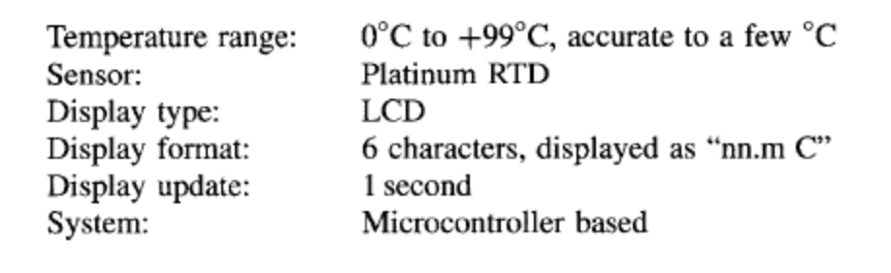
Design: RTDs from many manufacturers can be chosen for this project and a Standard Class B RTD

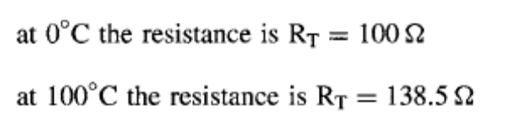

If we assume a source resistance of Rs = lk, and a source voltage of Vs = 5 V, the voltage across the RTD element at either end of the operating temperature.

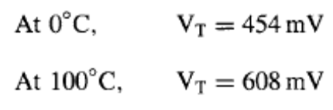

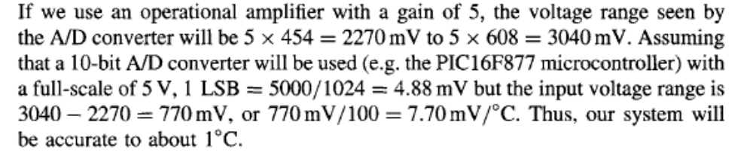
The block diagram of the project is shown in Fig. . The complete circuit diagram is shown in Fig. A standard RTD is connected to a +5 V constant voltage source. The voltage across the RTD is fed to an operational amplifier with a gain of 5. Low-pass filter circuit is not used here for simplicity.
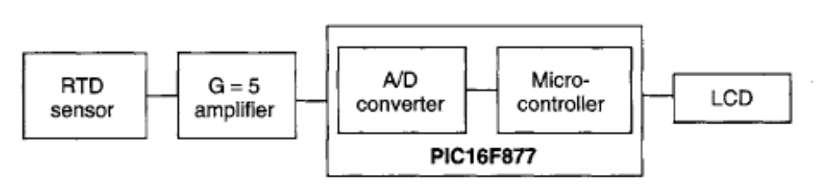
Block diagram of the temperature measurement system
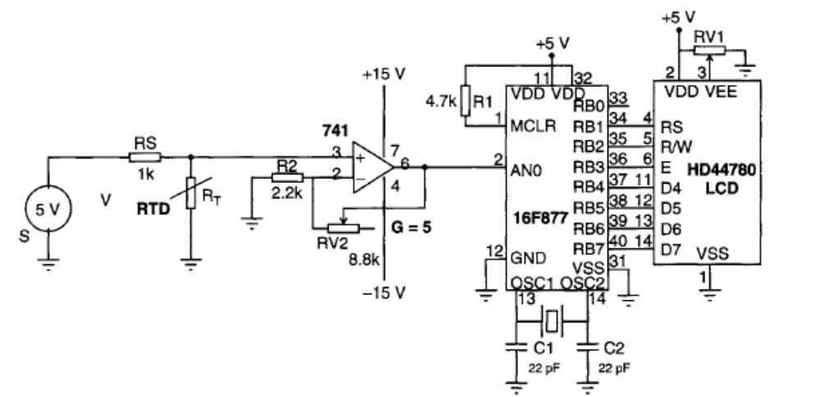
Circuit diagram of the temperature measurement system

Program listing
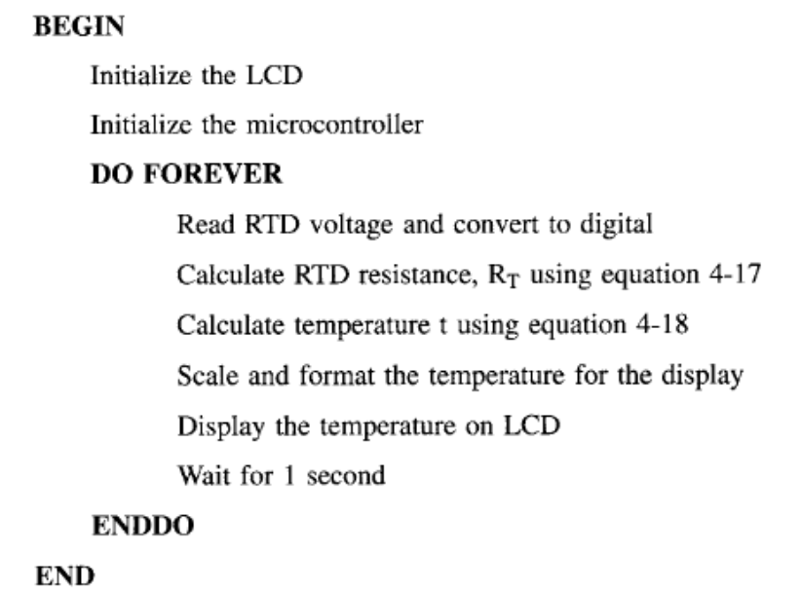
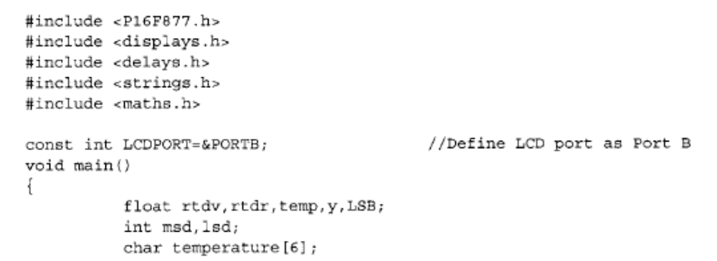

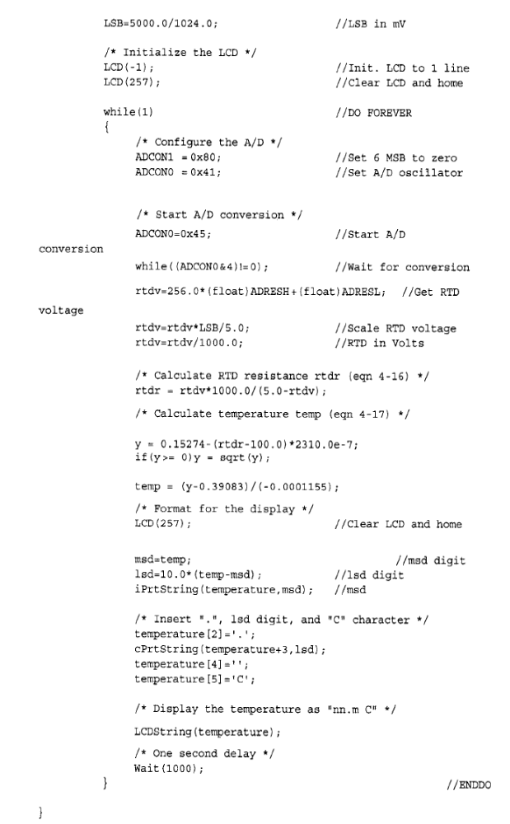
Hardware Implementation of a Microcontroller-Based Temperature Controller (Closed loop)

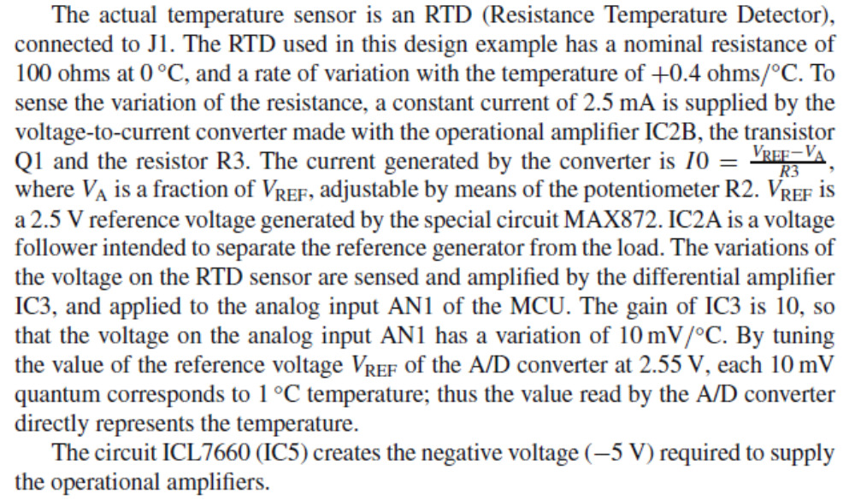
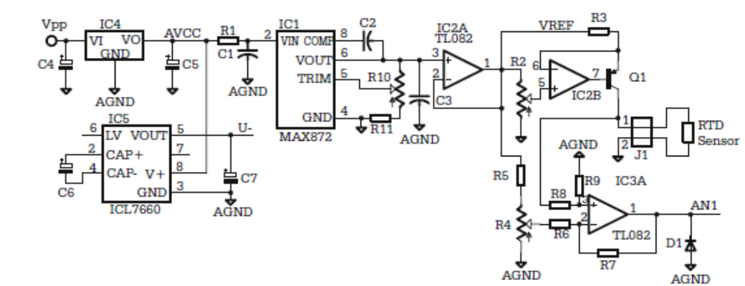

Figure shows the zero crossing detector circuit that generates a square wave out of the sine wave of the ac power. The output of this circuit is connected to PA0, which is also used as the input for the input capture 3 timer. The edges of this signal generate interrupt requests used by the software to synchronize the pulses that control the output triac. The same transformer that provides the ac voltage used by the zero crossing detector also provides the ac input for the bridge rectifier B1, which generates Vpp.

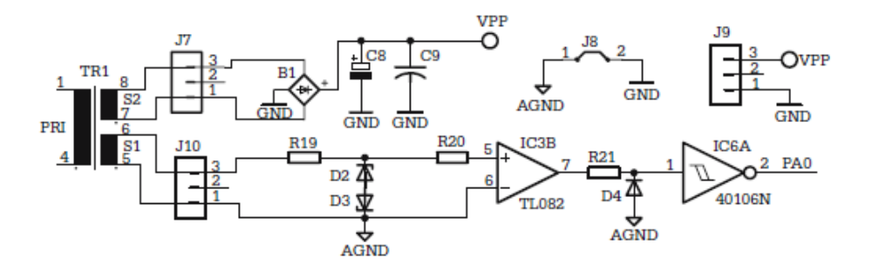

Schematic of the zero crossing detector

The heater is driven by the triac T2, controlled to open at precise time moments by the pulses generated by software on PA7, and transmitted to the gate of the triac by means of the transistor T1 and the pulse transformer L1, as shown in Fig

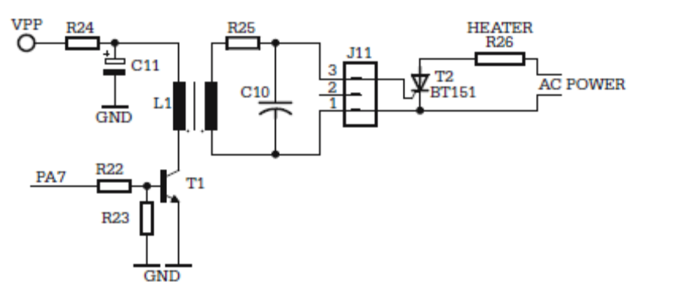

The gate control circuit of the triac

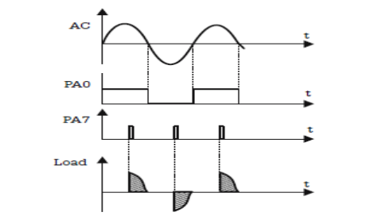

Waveforms explaining the operation of the gate control circuit

Remote Relay Controller over Telephone Lines

This example contains the description of a device that interfaces a microcontroller to a telephone line, and is capable of receiving and decoding a series of DTMF signals, and to execute commands received this way.

Description of the Hardware Solution

Since telephone lines are available almost anywhere, it is interesting to design a device that, when connected to a phone line, is able to answer a call, and to recognize and execute a series of commands generated directly from the keypad of the telephone set that initiated the call. This device operates according to the following set of rules:
• The human operator initiates a call, using a regular telephone set.
• The relay controller senses and counts the ring tones generated by the central office.
• After a specified number of rings, the relay controller answers the call and transmits a specific audible tone over the telephone line to acknowledge its presence.
• Using the telephone keypad, the operator generates a series of DTMF (Dual
Tone Multi Frequency) tones, having a determined structure, which are received and decoded by the controller. The DTMF tones are audio signals, consisting of a combination of two sine waves, having precise frequencies in the range 697–1633 Hz. Each key of the telephone set keypad is associated with a distinct combination of frequencies, so that the receiving device can easily identify the key pressed.
• The relay controller sends back to the operator distinct audible tones after the reception of correct, or erroneous DTMF series.
• After 30 seconds of inactivity, i.e. if no DTMF tone is received for 30 seconds, the controller closes the line, and terminates the session.

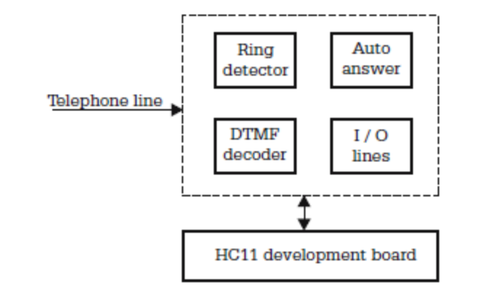

Block diagram of the remote relay controller

The telephone line interface comprises the following functional blocks: • The ring detector. This is the circuit that recognizes the ring tone, and informs the microcontroller about an incoming call.
• The auto-answer circuit. This allows the microcontroller to open the line and answer the call, after a specified number of rings.
• The DTMF decoder. This decodes DTMF tones received over the telephone line and reports the codes to the microcontroller, along with a STROBE signal. The DTMF tones are generated by the telephone set that initiates the call.
The schematics of the ring detector and auto-answer circuits are presented in Fig.
The device emulates the behavior of a standard telephone set. While in the onhook status, the capacitor C1 separates the interface from the telephone line, but allows the ring signal, which is an ac signal with amplitude 48–50 V, and frequency of approximately 30 Hz, to go through, towards the rectifier formed by D1, D2 and C2.

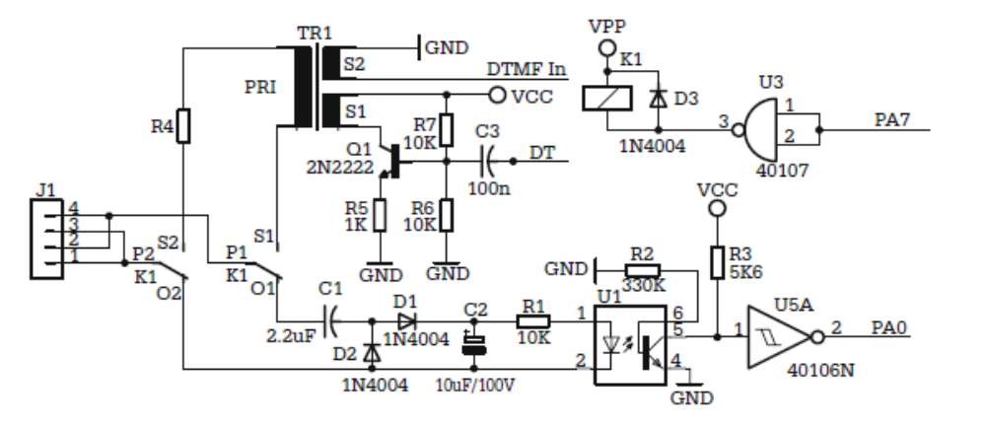
Ring detector and auto-answer circuits

The resulting dc voltage activates the LED of the optocoupler U1, which results in the saturation of the output transistor. The output of the optocoupler is conditioned and inverted by the Schmitt trigger gate U5A, and then applied to the PA0 (TIC3) input of the microcontroller. The rising edge of the signal on PA0 generates a TIC3 interrupt, thus informing the microcontroller about the detected ring.

After counting a programmed number of rings, the MCU activates the relay K1, by writing 1 to PA7, and opens the telephone line. In the off-hook status, the telephone line is connected to the primary circuit of the transformer TR1, in series with the resistor R4 (560 ohms), which gives a total load impedance of around 600 ohms, as required by all modern central offices.

Besides galvanic isolation, the transformer TR1 has two additional functions: it transfers the audio signal DTMF_IN from the telephone line to the input of the DTMF decoder, and, on the other hand, transmits the audible dialog tones DT, generated by the interface, to the telephone line, by means of the transistor Q1. The actual DTMF decoder is shown in Fig

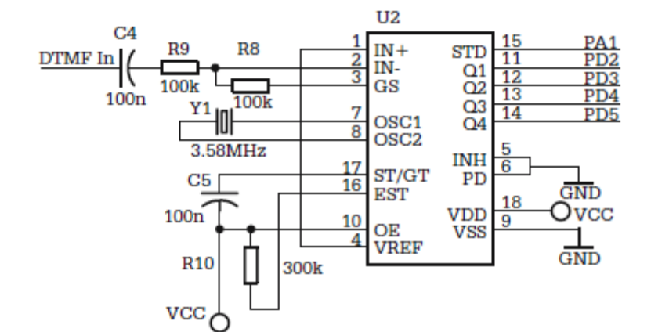

Schematic of the DTMF decoder circuit

The input for the decoder circuit CM8870 (U2) is the analog signal DTMF_IN, which is the analog signal present on the telephone line, separated by the transformer TR1, without further processing. When this signal contains a valid combination of tones, corresponding to the DTMF standard, the circuit presents on the output lines Q1–Q4 the 4-bit binary code of the digit associated with the DTMF tone, along with a strobe signal STD, active HIGH. STD stays HIGH as long as the DTMF tone is stable at the input of the circuit (min 100 ms).

shows the schematic of the circuit that generates the audible dialog tones DT, transmitted by the controller over the telephone line in response to the DTMF commands received. This is a classic multivibrator, built with NE555, calibrated to generate a square wave signal with frequency around 1 kHz.

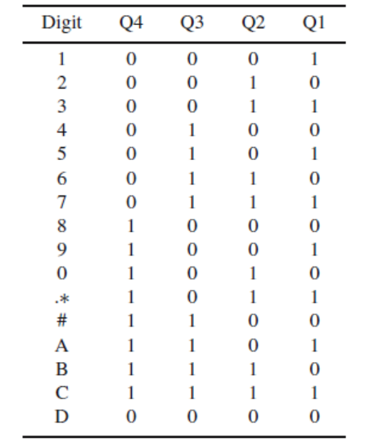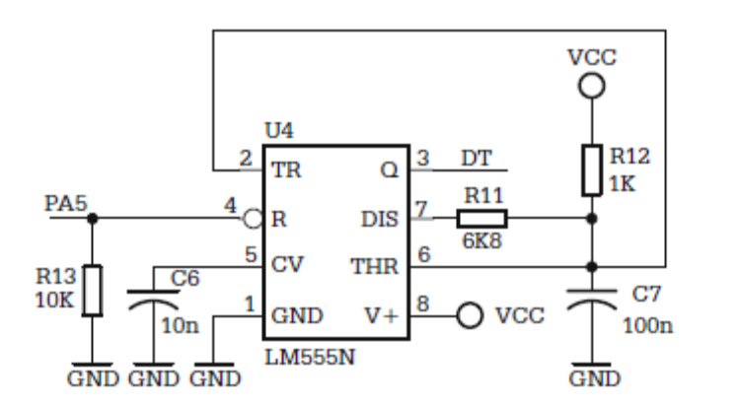
The binary codes associated with the digits of the telephone set keypad -- Schematic of the multivibrator that generates the dialog tones

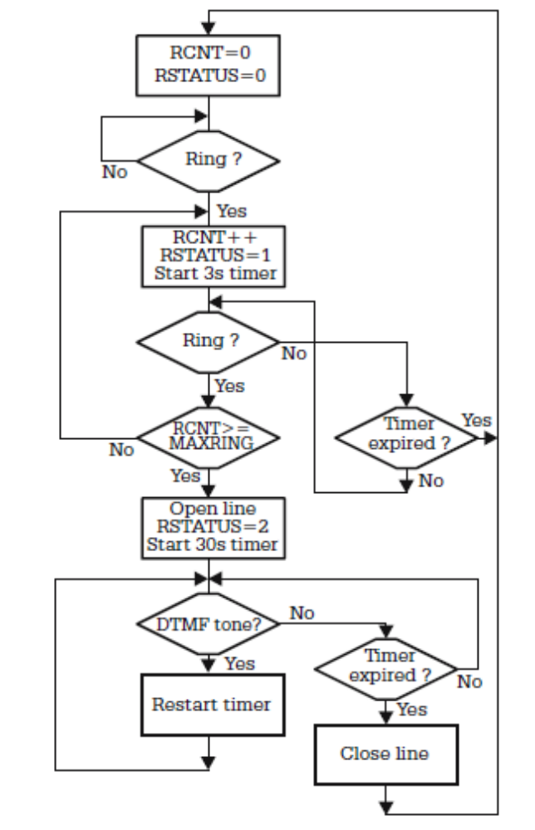

Logic diagram of the ring counter and auto-answer program

Refrences:

- Microcontrollers in Practice : Springer springeronline.com 2005
- Microcontroller Based Applied Digital Control : Dogan Ibrahim 2006
- Process Control ınstrumentation Technology, Curtis Johnson 7 th edition Prentice Hall 2002
- Microcontroller-based temperature monitoring and control : (Dogan Ibrahim – 2002)

